Official league roster - Soccer
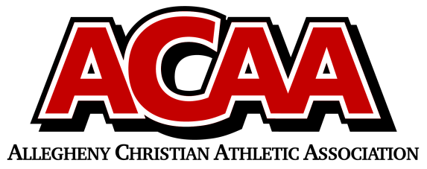

School Name: Johnstown Christian
Team Colors: Royal Blue &White
Overall Wins ___ Losses ____ Ties ___
ACAA Wins ___ Losses ____ Ties ___ OPPONENT: __________________________
Date: _________
Number | Name | Year | Position | Homeschool
9 | Lydia Hostetter | 12 | M | no
12 | Sybella Mack | 12 | F/M | no
10 | Ellie Speigle | 12 | M | no
20 | Olivia Lushko | 12 | D/M | no
19 | Hope Ressler | 11 | D/M | no
17 | Lily Lushko | 10 | Goalie/M | no
7 | Brair Claycomb | 10 | D | no
11 | Dani Coleman | 9 | D | no
5 | Noelle Lushko | 9 | F/M | no
6 | Oriana Yoder | 9 | M/F | no
15 | Sydnee Sorg | 9 | D | no
18 | Isabella Williams | 9 | Goalie/M | no
21 | Peyton Weyant | 9 | D | no
1 | Daisy Click | 8 | F | no
2 | Gianna Mallozi | 8 | F/M | no
16 | London Matsumoto | 8 | M/D | no
13 | Molly Coleman | 7 | D | no
3 | Ava Giardina | 7 | D/M/F | no

Head Coach: Jo Habecker
Asst. coach: Dave Sprankle
Asst. coach:

Official ACAA League Team Roster. to be submitted to the scorer’s table before each game.

